**Report 7.1P**

GitHub Repo: <https://github.com/Sperados/7.1P>

YouTube Demo: <https://youtu.be/8F6y61miqgI>

*Webpage before User Authentication:*

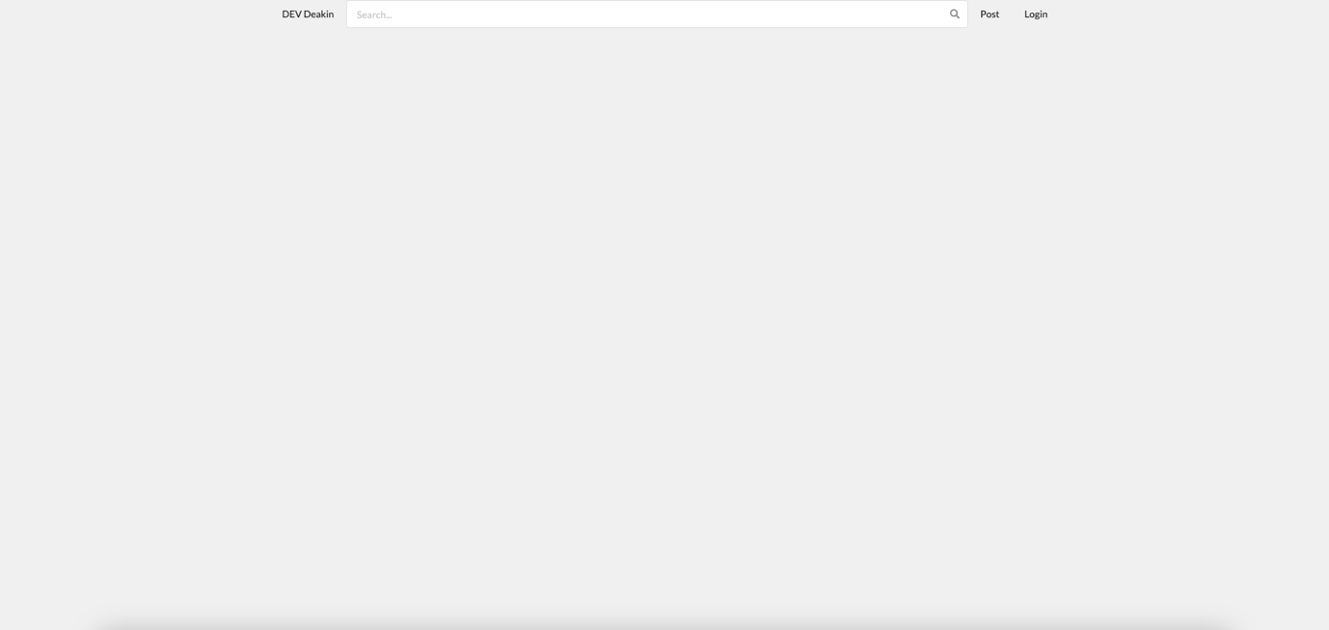

*Login Page:*

*Sign-up Page:*

*Webpage after User Authentication:*

